Figure 1. Quality Early Childhood Care and Education Concept Map
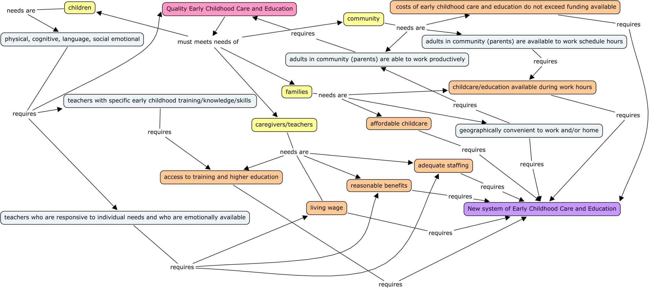
Orange boxes represent items in direct conflict with one another. In order to resolve items in conflict a new system of early childhood care and education in the United States must be created.

Figure 2. A New System for Quality Early Childhood Care and Education

Sophia Hubbell
Natural Environments
February 15, 2010
Short Paper #2

Policy Recommendations for Quality Early Childhood Care and Education

Quality early childhood care and education must meet the needs of all stakeholders including young children, families, caregivers/teachers, and the community. The purpose of this paper is to identify the necessary components of a quality early childhood care and education system by examining the needs of each stakeholder group. The results presented indicate the need for a new system of early childhood care and education in the United States in order to meet the needs of all stakeholders. Key components of a new system for early childhood care and education will be described.
Figure 1 defines the needs of each stakeholder group, illustrates the relationships between the needs of each stakeholder group and shows what is required to meet each need.
Children need to be cared for in an environment that promotes their physical, cognitive, language, and social-emotional development (WestEd, 2002). Caregivers need to earn living wages, have reasonable benefits, work in adequately staffed programs, and have access to relevant early childhood training and opportunities for higher education (WestEd, 2002). Families need affordable childcare (WestEd, 2002) that is available during their work hours and is geographically convenient to work and/or home. Finally, communities need for adults, namely parents, to be available to work during scheduled hours and to be able to work productively. Communities also need for early childhood care and education costs to not exceed available funding.
The orange items in figure 1 highlight seven needs that are in direct conflict with one-another. The link between each of these conflicting needs is funding. Resolution of these conflicts using existing funding requires a new system of early childhood care and education.
The new system relies on two key changes to the current system. First, childcare and education services must be combined for all children from birth until age-eligible for full-day public school. Second, the apprenticeship model of training needs to be the primary method of educating early childhood providers. Together, these two components will reduce the cost of care while increasing the quality of care, thereby meeting the needs of all stakeholders.
Currently in the United States, early childhood education, special education, and child care are provided separately with few exceptions. Further, special education services for children from birth to three are often provided separately from special education services for children ages three to five. Figure 2 lists the public and private services available under the current system and illustrates the merger of these services to create a new system for all children birth to school-age. Combining these services will reduce administrative, facility, and transportation costs as well as improving the quality of care through coordination of services. Further, families will benefit from elimination of transportation issues during work hours and the availability of quality care that is compatible with their work schedules.
By converting to an apprenticeship model of training tied into degree-granting programs at institutions of higher education, the quality of early childhood care and education will increase while reducing the costs of care. The current system of education and training for early childhood teachers relies primarily on short-term professional development workshops paired with formal coursework at higher education institutions (Burchinal, Cryer, Clifford, & Howes, 2002). The benefits of short-term professional development workshops are that they are inexpensive, readily available, and require little time commitment. However, Burchinal et al. (2002) found that formal early childhood teacher education (as evidenced by at least a bachelor’s degree) had a greater impact on the quality ratings of child care centers and on child outcomes than short-term workshops. By embedding formal early childhood teacher education programs into childcare centers, it will increase caregivers’ access to the training necessary for improving the quality of care for young children. Further, such a program will decrease adult-child ratios through the availability of low-cost student teachers and faculty thereby lowering teacher stress and turnover. Lower adult-child ratios, lower teacher stress, and lower turnover are all associated with increased quality of care for young children (WestEd, 2002).
Several studies have shown the long-term benefits of quality early childhood care and education in terms of child outcomes (e.g. Burchinal et al., 2002; Peisner-Feinberg et al., 2001). Further, numerous authors have described the essential components of quality early childhood care and education (e.g. Soodak, 2002; WestEd, 2002). However, the current system for early childhood care and education in the United States fails to provide quality care for all young children. Funding is the major barrier between current practices and recommended practices in early childhood care and education. This paper presented a new system for affordable, quality care for all young children.

References
Burchinal, M. R., Cryer, D., Clifford, R. M., Howes, C. (2002). Caregiver training and classroom quality in child care centers. Applied Developmental Science, 6(1), 2-11.
Peisner-Feinberg, E. S., Burchinal, M. R. Clifford, R. M., Culkin, M. L., Howes, C., Kagan, S.L., Yazejian, N. (2001). The relation of preschool child-care quality to children’s cognitive and social developmental trajectories through second grade. Child Development, 72(5) 1534-1553.
Soodak, L. C., Erwin, E .J., Winton, P., Botherson, M. J., Turnbull, A. P., Hanson, M. J., Brault, L. M. (2002). Implementing inclusive early childhood education: A call for professional empowerment. Topics in Early Childhood Special Education, 22(2), 91-102.
WestEd. (September, 2002). Infants and toddlers: Urgency rises for quality child care. WestEd Policy Brief. San Francisco, CA: author.

The terms caregiver and teacher will be used interchangeably throughout this paper to identify individuals who provide care for young children and who support the developmental needs of young children.

